1. Project Title:
Maze Solver Using State Space Tree and Shortest Path Algorithm

2. Team Members:
- Syed Sualeh Abbas
- Syed Arham Hussain
- Abdullah Naeem

3. Project Overview:
Our project aims to solve a maze problem using state space tree representation and a shortest path algorithm. We focus on representing the maze as a graph, where each cell in the maze becomes a node. From there, we explore all possible paths and find the shortest one to traverse from the Start (S) node to the End (E) node. This approach applies concepts of graph traversal, backtracking, and optimization techniques to find the most efficient route.

4. Problem Statement:
The maze problem is widely recognized in computational fields, especially in robotics and AI. The goal of this project is to automate the process of solving a maze by representing it as a state space tree. The challenge is to traverse the maze efficiently while avoiding obstacles and finding the shortest path from the start to the goal node. By using the shortest path algorithm, we aim to demonstrate an optimized approach to maze-solving.

5. Objectives:
- To represent the maze as a 2D grid (matrix).
- To convert the maze into a state space tree using valid movements (up, down, left, right).
- To apply a shortest path algorithm (Breadth-First Search) for finding the optimal route.
- To visualize the solution path from start to goal.
- To analyze the time and space complexity of the implemented algorithm.

6. Methodology:

1. Maze Representation:
The maze is represented as a matrix of size m x n, where:
- 0 = Walkable path
- 1 = Obstacle or wall
- S = Start position
- E = End position
For example:
maze = [
['S', 0, 1, 0],
[1, 0, 1, 0],
[1, 0, 0, 0],
[1, 1, 1, 'E']
]

2. State Space Tree:
The maze is treated as a state space tree, where each cell becomes a node. The directions of movement are up, down, left, and right. From each node, we explore all valid moves and expand the tree until we reach the goal or exhaust all possibilities.
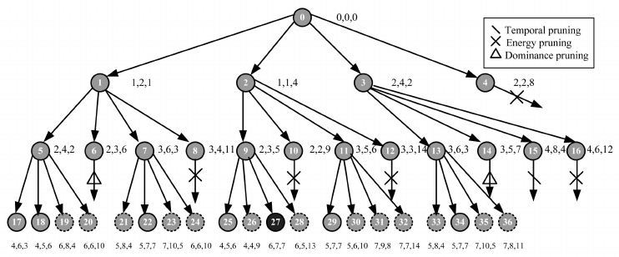

3. Shortest Path Algorithm:
We use Breadth-First Search (BFS) for this project because:
- BFS explores all possible paths level-by-level.
- It guarantees the shortest path in an unweighted graph (such as our maze).
- BFS ensures the most efficient path is found by expanding the search incrementally.

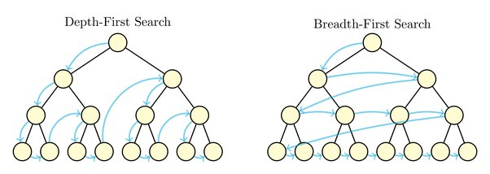

4. Implementation Details:
Input: A 2D matrix representation of the maze.
Process:
- Convert the maze into a state space tree.
- Use BFS to explore all possible paths.
- Keep track of visited nodes to prevent reprocessing.
- Once the goal is reached, output the path taken.
Output: The maze matrix with the shortest path highlighted.

7. Testing:
We tested the maze solver with a variety of maze configurations:
- Simple mazes with clear paths from start to goal, where the algorithm successfully solved them.
- Mazes with dead ends, where BFS correctly backtracked and found alternative paths.
- Large mazes with a larger grid size, proving the algorithm’s scalability and efficiency.

8. Expected Outcomes:
- A functional maze solver that correctly identifies the shortest path.
- A visual output that shows the path taken from start to goal.
- Efficient performance, even with larger maze sizes.

9. Tools & Technologies Used:
- Programming Language: Python
- Libraries: collections.deque (for queue in BFS)
- Data Structures Used: Matrix (2D List), Set, Queue

10. Project Timeline:
Week | Tasks
Week 1 | Research pathfinding algorithms, implement BFS
Week 2 | Code maze input and visualization
Week 3 | Implement BFS for shortest path solution
Week 4 | Test with multiple mazes, refine and optimize

11. Conclusion:
This project allowed us to explore and implement graph traversal techniques, specifically BFS, to solve a maze problem efficiently. We gained valuable insights into:
- Representing real-world problems as state space trees.
- Optimizing pathfinding algorithms.
- Analyzing computational efficiency in terms of time and space complexity.
Future Work:
- GUI implementation for better visualization using libraries like Tkinter or Pygame.
- Compare BFS with other pathfinding algorithms such as A* or Dijkstra.
- Expand to 3D mazes or incorporate more complex movement patterns.

